# GMNS-AMS Network Modeling

## Case Study: University District of Seattle

**Introduction**

The GMNS-AMS network modeling consists of 7 major steps. 0. Obtain Open street map. 1. Transfer OSM map into GMNS (General Modeling Network Specification) 2. Transfer GTFS (General Transit Feed Specification) public transit data into GMNS format. 3. Generate Cell-based (microscopic, mesoscopic, and macroscopic) Networks. 4. Generate zone-to-zone travel demand based on alphanumeric grid zones. 5. Traffic signal API for multi-resolution modeling (software package is under development). 6. AMS simulation, including DTALite, an AMS software package for efficiently macroscopic traffic assignment based on GMNS format. 7. Using QGIS and NeXTA for data visualization

The AMS-GMNS modeling flow can be demonstrated as the below table.

|  |  |  |  |  |
| --- | --- | --- | --- | --- |
| Step |  | Input File | Output File | Software Packages |
| 0 | Map Data Download | -- | -- | Open Street Map |
| 1 | Transfer OSM to GMNS | Map.osm | Node.csv, Link.csv, poi.csv, | OSM2GMNS |
| 2 | Transfer GTFS Data to GMNS | Open transit.osm | Node.csv, Link.csv, Poi.csv, | GTFS2GMNS |
| 3 | Transfer Node Link Data to Micro, Mesco and Marco | Node.csv, Link.csv, | Micro, Mesco and Marco | Net2cell |
| 4 | Zone-to-zone Travel Demand | Node.csv, Link.csv, Poi.csv, | Demand.csv, Poi_trip_rate.csv, Zone.csv, Accessibility.csv | Grid2demand |
| 5 | Traffic signal for Timing | -- | -- | Signal2timing (In development) |
| 6 | AMS Simulation | Demand.csv, Node.csv, Link.csv, | Agent.csv | DTAlite, STAlite |
| 7 | Visualization | -- | -- | QGIS, NeXTA |

**The Demonstration of Modeling Steps Based on The University District of Seattle (University of Washington)**

**Step 0: Determine the research boundary and download .osm file from OpenStreetMap.**

The open street website allows to Adjust the map to the location of interest and directly download an OSM data file.

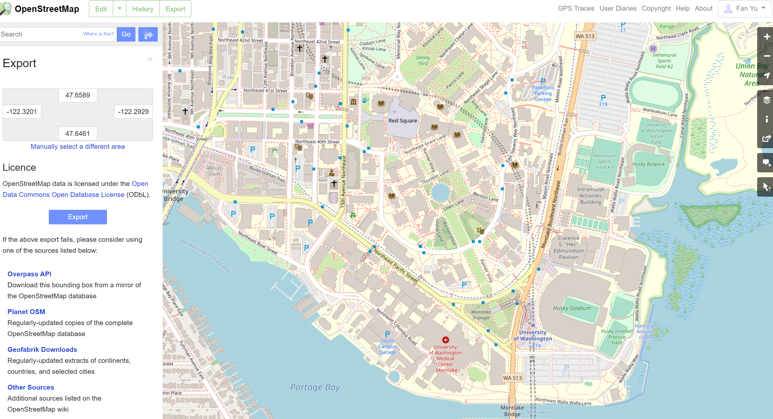

However, the purpose of the networking modeling is to support the developing of A/B Street traffic simulation software. <https://github.com/dabreegster/abstreet>

The default map of A/B street is a detailed map of Seattle, and we are using University District as a case study. The boundary and the OSM map are the same used in the software.

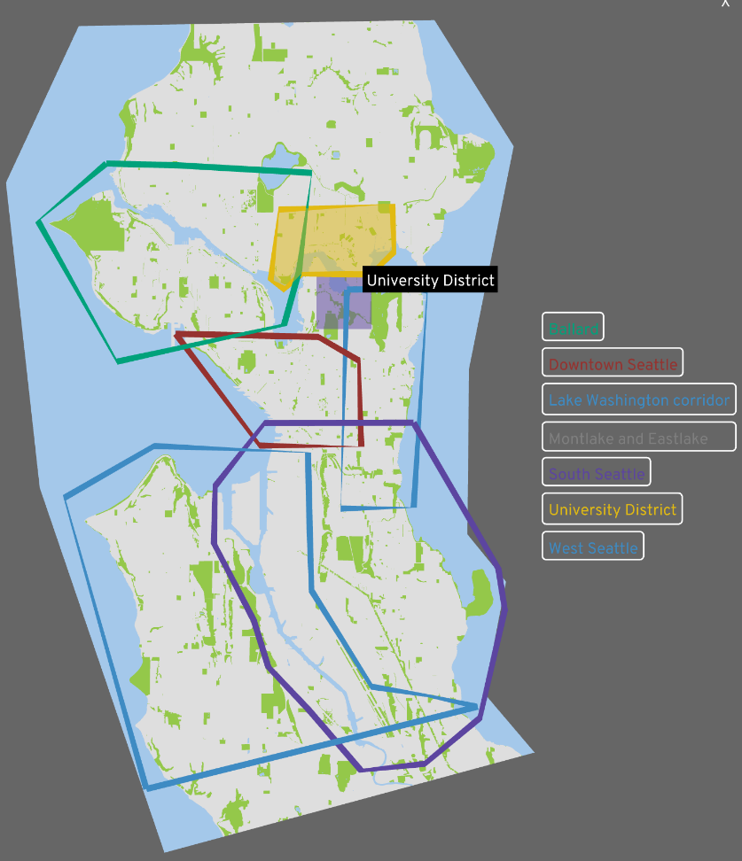



**Step 1: Execute OSM2GMNS to get network files in GMNS format**

Open the Python IDE such as Pycharm for a typical configuration. Then, OSM2GMNS converts *map.osm* file in OSM format into a network file in GMNS format.

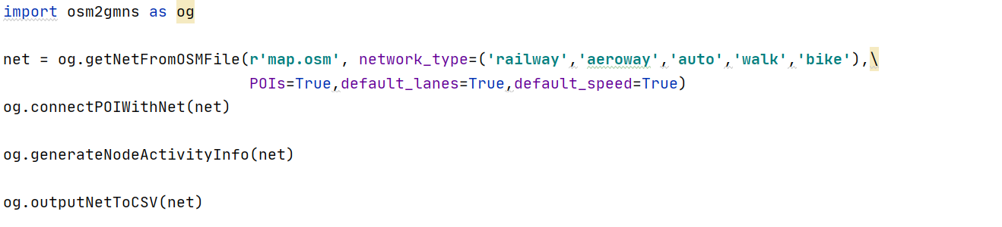

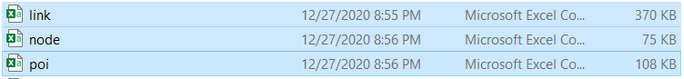

**Step 2: Execute GTFS2GMNS to get bike and walk network in GMNS format**

You only need the following 4 lines of python codes, it can directly convert the GTFS data to node, link, and agent files in the GMNS format. Comparing with walk mobility and bike mobility of Univeristy of Washington, there is only subtle difference on the map.



Walk mobility network at UW (Pink)

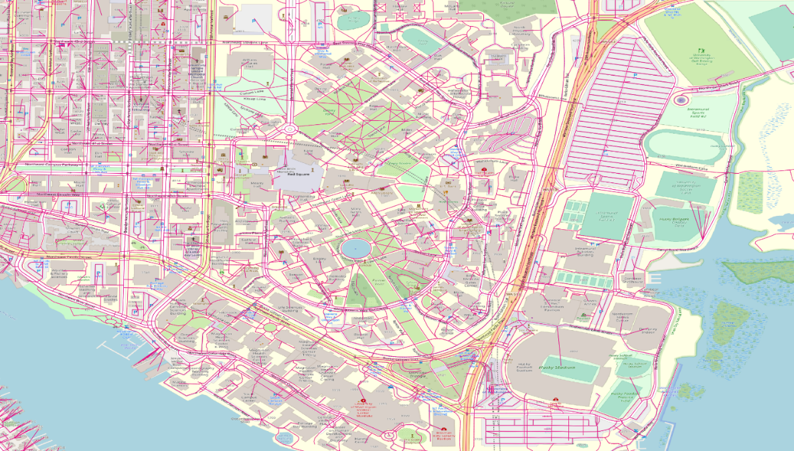

Bike mobility network at UW (Blue)

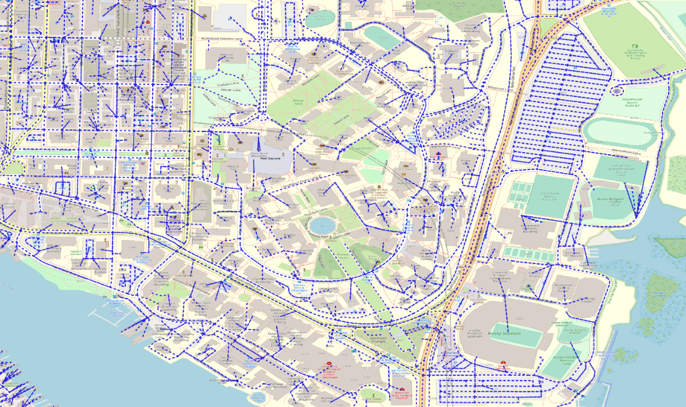

Bike + Walk

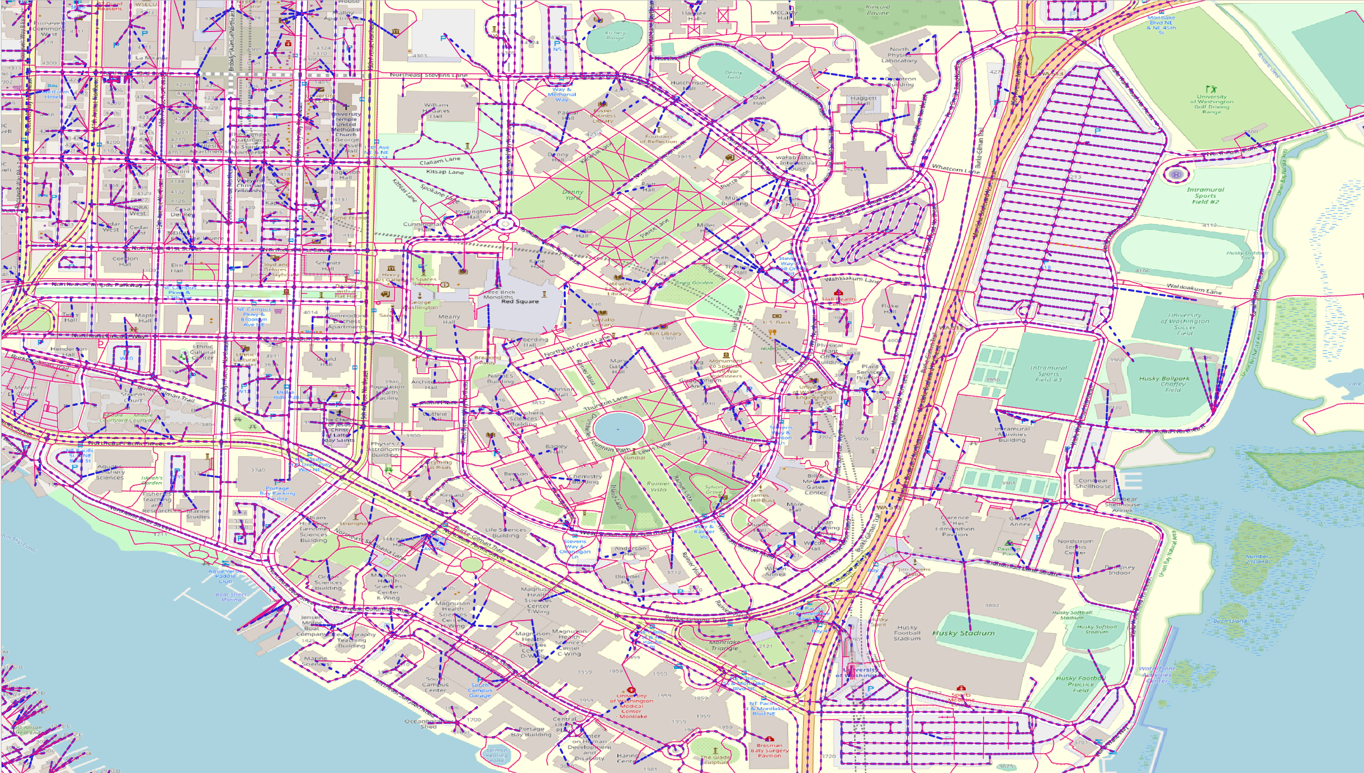

**Step 3: Execute net2cell for microscopic, mesoscopic, and macroscopic networks.**

Running net2cell package to obtain the microscopic, mesoscopic, and macro networks. The input data should be the node and link data from the OSM2GMNS.

Macroscopic Network:

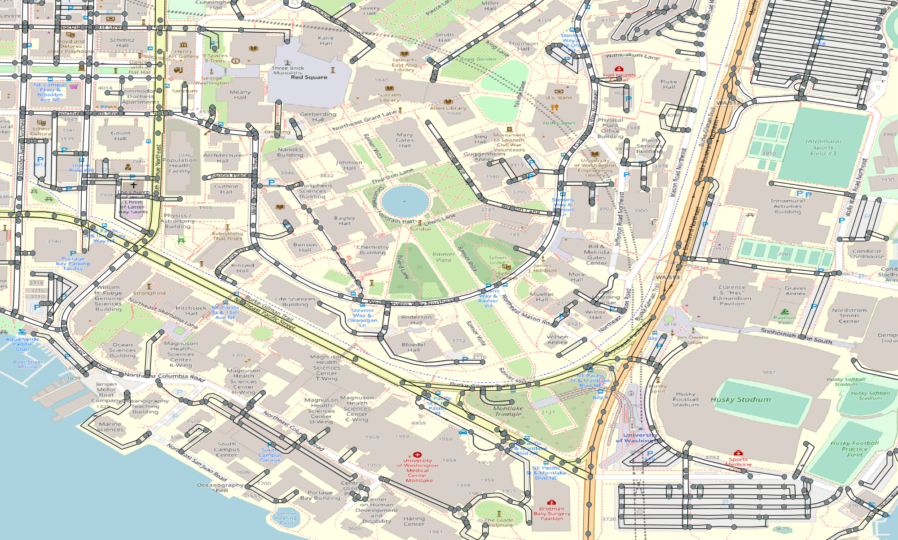

Mesoscopic Network:

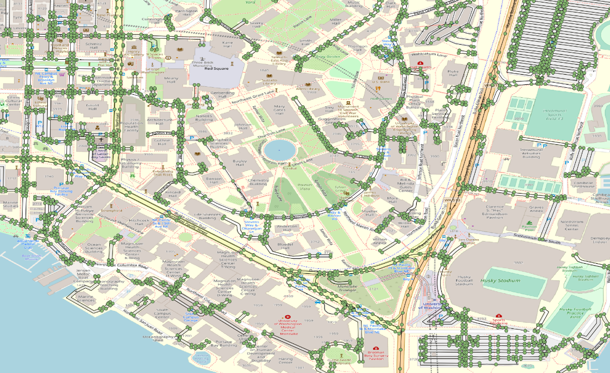

Microscopic Network:

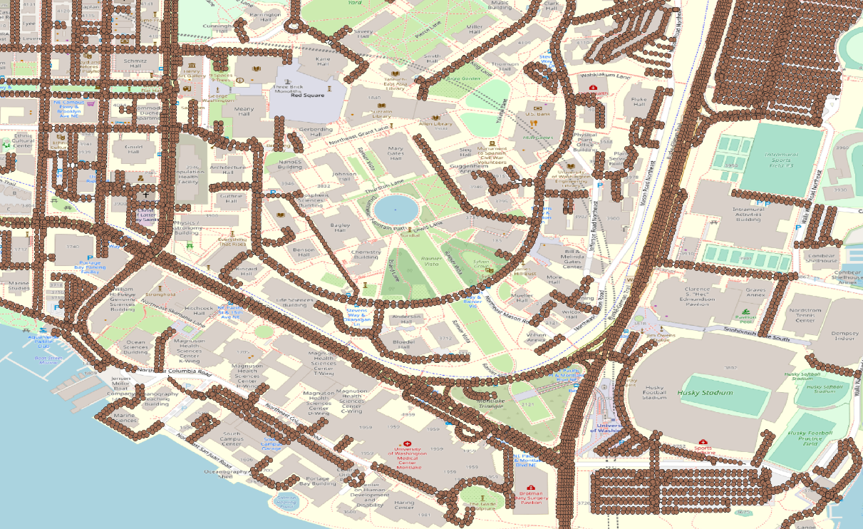

**Step 4: Execute GRID2DEMAND Python code**

Configurate working dictionary in the Python IDE (e.g., Pycharm). Then, execute GRID2DEMAND to get zone-to-zone demand, generating four files which are highlighted in blue.

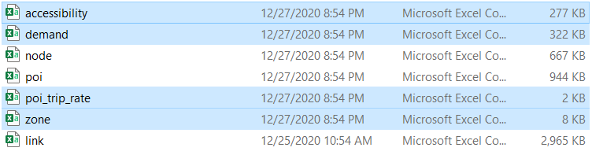

**Step 5: Signal2timing: software package is still developing based on Python.**

**Step 6: AMS simulation: Under testing**

**Step 7: Visualization in QGIS**

Open QGIS and add Delimited Text Layer of the output files.

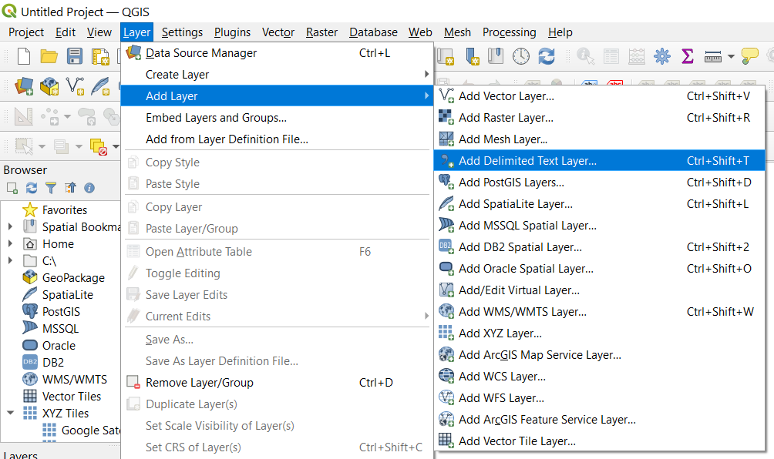

Then Open the Properties window of the demand layer. Set the symbology as graduated symbols by size.

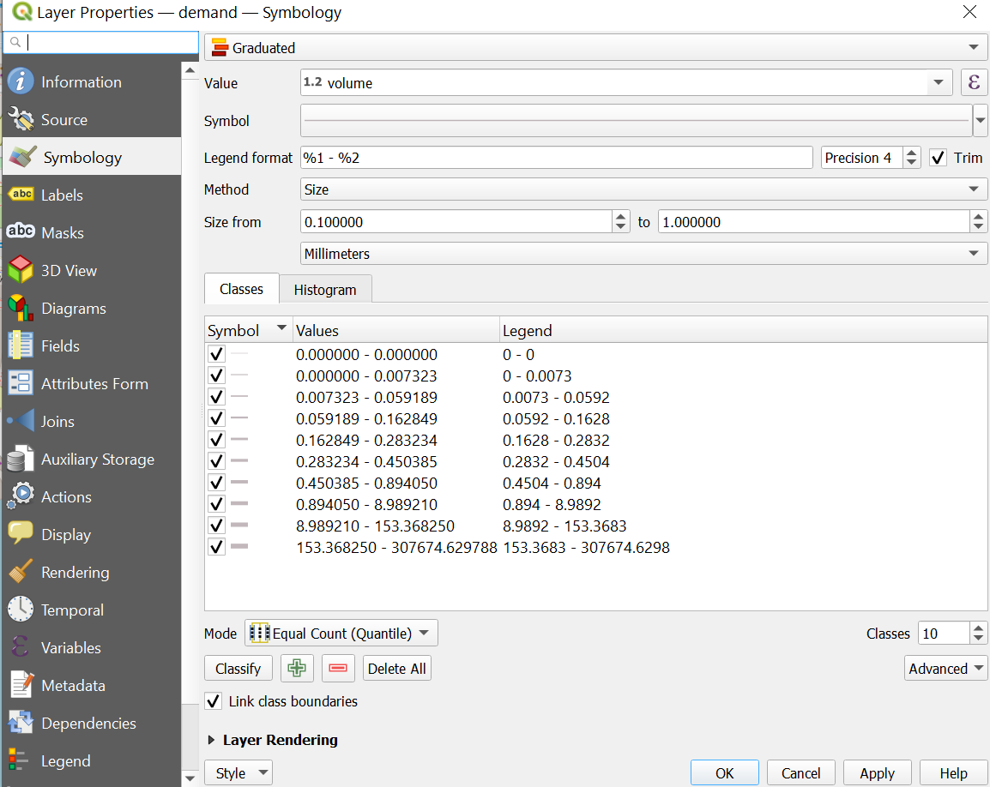

Zone-to-zone demand can be visualized with a base map of University District.

